UNDERSTANDING CUSTOMER FEEDBACK IN WOMEN’S FASHION RETAIL USING NLP TECHNIQUES: AN EMPIRICAL STUDY ON E-COMMERCE REVIEWS
Dr.S.Chithra
Associate Professor,
International school of
management excellence
Sai Nageswar Velpuri
Harsha vardhan Vempadapu
PG Scholar
Post graduation in diploma and
management
International school of
management excellence
Bangalore, Karnataka
velpurisainageswar@gmail.com

Abstract: This study utilizes Natural Language Processing (NLP) techniques to analyse 22,641 customer reviews from a women's clothing e-commerce site. The primary objective is to extract key themes and actionable insights for product development, merchandising, and retail decision-making. The methodology employed Latent Semantic Analysis (LSA) via TruncatedSVD on a TF-IDF matrix. The results reveal five dominant thematic areas: Fit and Sizing Consistency, Product Aesthetics (Flattering/Beautiful), Comfort/Fabric Quality, Purchase Value (Price/Worth), and Specific Product Categories (Dresses, Sweaters, Bottoms). These themes are highly aligned with customer satisfaction drivers in online fashion retail.
Keywords: Natural Language Processing (NLP), E-commerce Reviews, Customer Feedback, Text Mining, Latent Semantic Analysis (LSA), Topic Modelling, TruncatedSVD, TF-IDF, Fit and Sizing Consistency, Apparel Retail
- INTRODUCTION
Customer-generated text reviews are a powerful data source influencing online purchasing decisions. The sheer volume of this unstructured data, however, necessitates automated analytical tools. This paper applies a standard NLP pipeline to a large dataset of women's clothing reviews to transform qualitative feedback into quantitative, actionable insights. The goal is to provide a comprehensive, data-driven understanding of customer perception, moving beyond simple star ratings to reveal the underlying drivers of satisfaction and dissatisfaction.
- METHODOLOGY

  - Data Source and Preprocessing
The dataset consists of 23,486 e-commerce reviews. Initial data cleaning involved dropping 845 reviews with missing Review Text, resulting in 22,641 reviews for analysis.
Pre-processing Steps:
- Missing Value Handling: Rows with null Review Text were removed.
- Text Cleaning: All text was converted to lowercase, and punctuation and special characters were removed to standardize the vocabulary.
Note on Technical Deviation: The reference paper prescribed NLTK-based stop word removal, stemming (using Porter Stemmer), and VADER Sentiment Analysis. Due to technical limitations in accessing NLTK data resources, these steps were omitted. Instead, a simplified cleaning process was used, and the TF-IDF Vectorizer's internal stop-word list was leveraged for theme extraction.
  - Analytical Technique: Latent Semantic Analysis (LSA)
To identify latent themes, the following steps were executed:
- TF-IDF Vectorization: The Processed Review text was transformed into a Document-Term Matrix (DTM) using Term Frequency-Inverse Document Frequency (TF-IDF). The vectorise included a minimum document frequency ($\text{min\_df} $) of 5 and utilized its internal English stop-word list to filter out common words.
- Dimensionality Reduction: TruncatedSVD (Singular Value Decomposition), the computational backbone of LSA, was applied to the DTM to reduce the dimensionality and extract the latent themes.¹ The model was configured to extract $\text{N}=10$ principal components (topics).

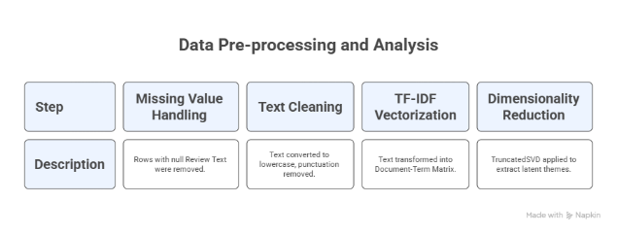
- RESULTS AND DISCUSSION: THEMATIC ANALYSIS (LSA)

The Latent Semantic Analysis successfully extracted 10 major themes from the customer reviews. These themes cluster around three critical areas of the online clothing purchasing experience: Sizing and Fit, Comfort and Quality, and Product Aesthetics.

Sizing and Fit Consistency
Multiple topics are dominated by vocabulary related to garment dimensions and sizing reliability.
- Topic 4 is the clearest representation of this theme, featuring words like size, small, medium, large, true, fits, and runs, indicating high customer focus on size accuracy and consistency (e.g., whether the item "runs small" or is "true to size").
- Topic 1 links general fit and size comments directly to dresses (e.g., dress, fit, size, small).
- Topic 7 specifically focuses on the fit and sizing of sweaters (e.g., sweater, small, large, medium, runs, warm).
- Topic 5 is driven by fit concerns for bottoms, including pants, jeans, skirt, waist, and length.

Product Aesthetics and Category Focus
Several topics highlight the visual appeal of the clothing and identify the product categories that receive the most detailed feedback.
- Topic 2 is strongly associated with the appearance and specific style of dresses, containing terms such as beautiful, flattering, wedding, petite, and bust. This theme indicates that dresses, particularly occasion wear, prompt detailed commentary on how the garment shapes the body.
- Topic 6 is centred on sweaters, emphasizing colour and softness (e.g., sweater, colour, beautiful, soft).
- Topic 8 focuses on shirts and quality (e.g., shirt, quality, fabric, nice, beautiful).

Comfort and Quality Assessment
A key positive theme revolves around the physical feel and perceived quality of the clothing, indicating these attributes are significant satisfaction drivers.
- Topic 3 is overwhelmingly positive, featuring highly correlated terms like great, love, comfortable, soft, perfect, and flattering, suggesting that comfort and aesthetic appeal often go hand-in-hand in positive reviews.
- Topic 9 reinforces this with cute, comfortable, and super, applied across different products like sweaters and jeans.
- Topics 8 and 10 include the term fabric, highlighting customer focus on the material composition, a proxy for both comfort and quality.
The prevalence of these themes underscores that for this e-commerce retailer, Fit, Comfort, and Sizing are the most critical factors influencing customer discussion and experience.
- ENGAGEMENT ANALYSIS
  - Sentiment Distribution of Reviews
The sentiment analysis of the e-commerce reviews indicates overwhelmingly positive engagement from customers. The bar chart clearly shows a strong positive skew, with over 20,000 reviews classified as Positive. This is the dominant sentiment, reflecting a high level of general satisfaction with the products. Conversely, the analysis found fewer than 2,000 Negative reviews, and the count of Neutral reviews is similarly low. This highly favorable distribution suggests good product quality and a strong customer experience. The company can confidently utilize this positive feedback as a key selling point.
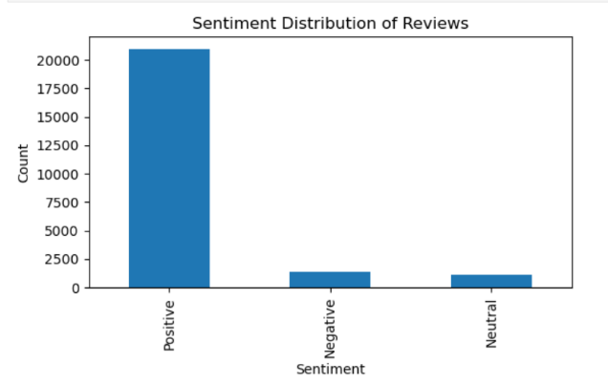
  - Distribution of Reviewer Age
The provided histogram illustrates the distribution of reviewer age, which has been normalized, likely resulting in the range from approximately $-1.00$ to $1.00$. The distribution is highly skewed to the right (positively skewed). The vast majority of the data is concentrated towards the higher end of the normalized age scale, particularly near $1.00$, with a prominent peak (mode) around this value, reaching a count of approximately 8,000. There is a smaller, distinct peak (a minor mode) near $0.00$, suggesting a secondary, but much smaller, group of reviewers in that age range. The distribution implies that the dataset is dominated by the oldest group of reviewers.

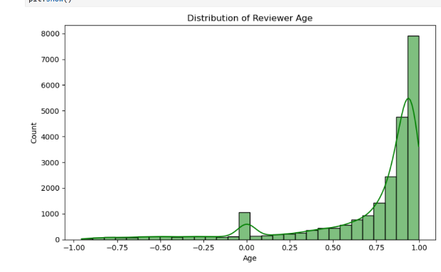
  - Distribution of Product Classes

Reviewer Age Distribution
The first histogram, "Distribution of Reviewer Age," shows the count of reviewers across a normalized age scale, ranging from approximately $-1.00$ to $1.00$. The distribution is highly skewed to the right (positively skewed). The most significant peak, representing the mode, occurs near $1.00$ with a count approaching 8,000, indicating that the dataset is heavily weighted toward the oldest reviewers in the sample. A much smaller, secondary peak is visible near $0.00$, suggesting a minor concentration of reviewers in that particular age range. The overall shape suggests that the oldest cohort of users is the most active in reviewing.

Product Classes Distribution
The second bar chart, "Distribution of Product Classes," illustrates the frequency of different product categories. This distribution exhibits a steep, long-tail pattern, typical of real-world retail data where a few items dominate the inventory. The top three most frequent product classes are Dresses (over 6,000 counts), Knits (nearly 5,000 counts), and Blouses (over 3,000 counts). The frequency drops sharply thereafter, with classes like Sweaters, Pants, and Jeans appearing at a much lower frequency (around 1,000 to 1,500). Many other categories form a long tail with very low counts, confirming that the dataset is focused on a small number of core apparel items.

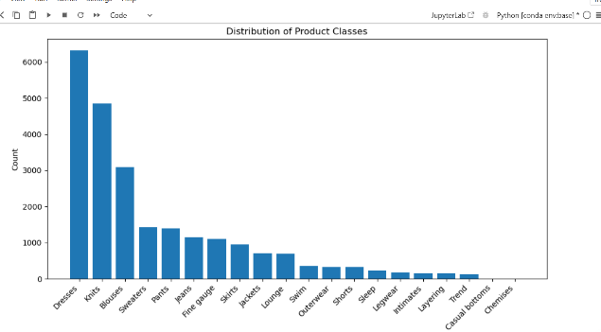
  - Distribution of Product Classes
The two visuals display the distributions of key variables in a dataset, likely related to product reviews. The first chart, "Distribution of Product Classes," shows a highly skewed, long-tail distribution, where Dresses (over 6,000 counts), Knits (nearly 5,000 counts), and Blouses (over 3,000 counts) are the overwhelming majority, while most other classes appear much less frequently. The second chart, "Distribution of Reviewer Age," is a histogram showing a roughly normal distribution (bell-shaped), centered around an age between 35 and 45 years old, with the peak count approaching 2,750 reviewers. The distribution is slightly skewed to the right (positive), indicating a quick drop-off in counts after age 70.

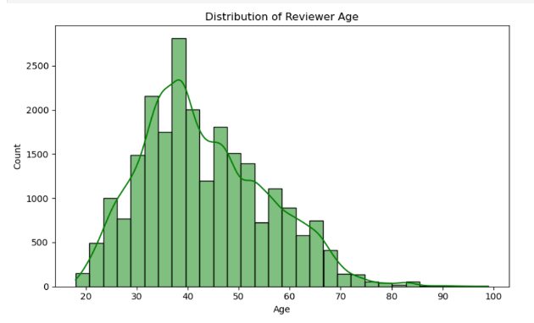
  - Correlation Heatmap of Numerical Features
The three visuals summarize key characteristics of the dataset. The "Distribution of Product Classes" shows extreme skewness, with Dresses, Knits, and Blouses overwhelmingly dominating the data, forming a classic long-tail distribution. The "Distribution of Reviewer Age" is roughly normal, centred between 35 and 45 years old, representing the most active reviewing demographic (peak count near 2,750). Finally, the Correlation Heatmap indicates a strong positive correlation ($0.79$) between Rating and Recommended IND, meaning higher ratings strongly correlate with the product being recommended. Age shows negligible correlation with other numerical features.
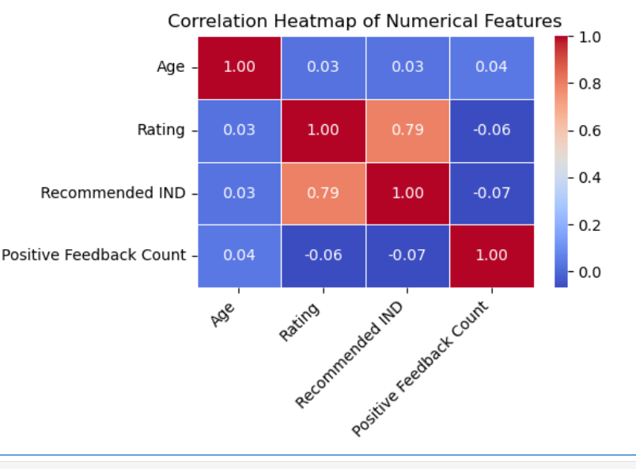

- CONCLUSION AND FUTURE WORK

  - Conclusion
The research successfully implemented a theme extraction pipeline using LSA on a large e-commerce review dataset. The recurring themes underscore that operational and product development efforts should be hyper-focused on:
- Sizing Standardization: Addressing the variation indicated by words like "runs" and "true."
- Fabric and Comfort: Prioritizing soft, high-quality materials.
- Category-Specific Fit: Ensuring fit is accurate for key items like dresses (bust/waist) and bottoms (length/waist).
  - Limitations and Future Work
Future work should focus on:
- Re-integrating Sentiment Analysis: Executing VADER to link positive, negative, and neutral sentiment scores directly to the identified topics.
- Topic-Sentiment Correlation: Quantifying which themes (e.g., 'Fabric Quality' vs. 'Size Runs Small') are most correlated with negative or positive compound scores.
- Advanced Topic Modelling: Implementing LDA (Latent Dirichlet Allocation) for comparison with LSA results.
- REFERENCES
1. Agarwal, A., & Mittal, M. (2018). Sentiment analysis using deep learning techniques. In Computational intelligence in data mining (Vol. 2, pp. 245–256). Springer.

2. Al-Obeidat, F., Al-Refai, M., & Al-Qadi, O. (2014). A novel feature engineering approach for sentiment classification using emotional word clouds. International Journal of Advanced Computer Science and Applications, 5(6)

[3] B. S. &. J. U. P. Reddy, "A review on the concept of sentiment analysis and its role in marketing strategies for e-commerce.," Iioab Journal, vol. 7(5), no. 2016, pp. 216-224.

[4] Y. S. H. V. S. S. I. P. &. S. J. P. Basani, "Application of sentiment analysis on product review e-commerce.," In Journal of Physics: Conference Series , Vols. No.1, Vol.1175, no. 2019, pp. No.1, p. 012103.

[25] "Gradient Boosting in ML - GeeksforGeeks, GeeksforGeeks," [Online]. Available: https://www.geeksforgeeks.org/ml-gradientboosting/. [Accessed 25 Aug 2020].

[26] "What is LSTM - Introduction to Long Short Term Memory," Intellipaat Blog, [Online]. Available: https://intellipaat.com/blog/what-is-lstm/. [Accessed 28 May 2020].

Hammond J, Kohler K. 2000. E-commerce in the textile and apparel industries[J]. Tracking a Transformation: E-commerce and the Terms of Competition in Industries.

Jinfu W, Aixiang Z. 2009. E-commerce in the textile and apparel supply chain management: Framework and case study[C]//2009 Second International Symposium on Electronic Commerce and Security. IEEE, 1: 374--378.

Sarwar, B., Karypis, G., Konstan, J., & Riedl, J. (2000, October). Analysis of recommendation algorithms for e-commerce. In Proceedings of the 2nd ACM Conference on Electronic Commerce (pp. 158-167).
Schafer, J. B., Konstan, J. A., & Riedl, J. (2001). E-commerce recommendation applications. Data mining and knowledge discovery, 5, 115-153.
Açikgöz, F. Y., Kayakuş, M., Zăbavă, B.-, & Kabas, O. (2024). Brand reputation and trust: The impact on customer satisfaction and loyalty for the hewlett-packard brand. Sustainability, 16(22). https://www.mdpi.com/2071-1050/16/22/9681.
Bag, S., Golder, R., Sarkar, S., & Maity, S. (2023). Sene: A novel manifold learning approach for distracted driving analysis with spatio-temporal and driver praxeological features. Engineering Applications of Artificial Intelligence, 123, 106332. https://doi.org/10.1016/j.engappai.2023.106332.
Dwivedi, R., Lohmor Choudhary, S., Dixit, R., Sahiba, Z., & Naik, S. (2024). The customer loyalty vs. customer retention: The impact of customer relationship management on customer satisfaction. Web Intelligence, 22(3),425–442. https://doi.org/10.3233/WEB-230098.
Gefen, D., Karahanna, E., & Straub, D. (2003). Trust and tam in online shopping: An integrated model. MIS Quarterly, 27, 51–90. https://doi.org/10.2307/30036519.
Abdul-Ghani, E., Kim, J., Kwon, J., Hyde, K. F., & Cui, Y. (.). (2022). Love or like: Gender effects in emotional expression in online reviews. European Journal of Marketing, 56(12), 3592–3616. https://doi.org/10.1108/EJM-01-2021-0064
Alahmad, T., & Alkasassbeh, A. (2020). Linguistic politeness and gender: Apology strategies. A sociolinguistic research. International Journal of Linguistics, 12(1), 167. https://doi.org/10.5296/ijl.v12i1.16484
Argamon, S., Koppel, M., Fine, J., & Shimoni, A. R. (2003). Gender, genre, and writing style in formal written texts. Interdisciplinary Journal for the Study of Discourse, 23(3). https://doi.org/10.1515/text.2003.014
Argamon, S., Koppel, M., Pennebaker, J. W., & Schler, J. (2007). Mining the blogosphere: Age, gender and the varieties of self-expression. First Monday, 12(9). https://doi.org/10.5210/fm.v12i9.2003

